**CloudPlatform**



Self Service Desktops

Installation Guide

  
www.citrix.com

Introduction

This document describes how to install the Citrix Self Service Desktops solution. The solution builds on work by Christian Ferber, and references his original documentation [1][2][3].

Objectives

CloudPlatform is a comprehensive cloud management solution which includes self-service capabilities. Many customers want to leverage self-service functionality for their virtual desktop installations to provide a portal where the user can select the desktop flavor he requires. In addition it should give the users more control over their desktops like start, stop, reboot, console access, network attach, attach ISO, attach volumes, console access and more. At the same time the performance to access the desktop should be optimal – hence XenDesktop with HDX capabilities should be used.

Overview

The Citrix Self Service Desktops solution provides a simple way for end users to self-provision desktops. Desktops are hosted in Citrix CloudPlatform, HDX access to the desktop is provided by Citrix XenDesktop.

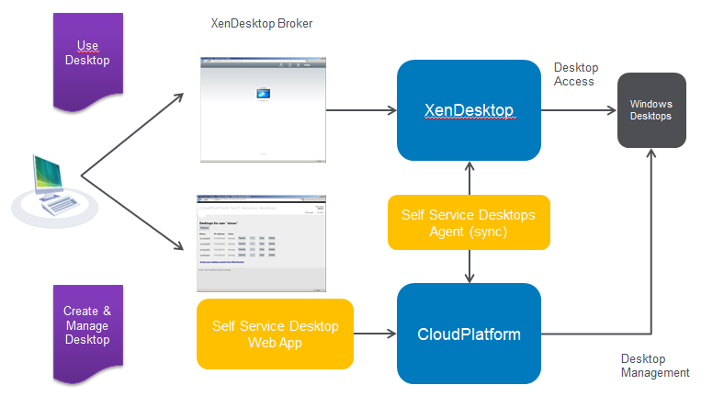

The above diagram illustrates the overall architecture of the solution. The Citrix Self Service Desktops Web App provides a simple, intuitive web UI to allow a desktop user to create desktops on demand, power manage the desktops, and delete desktops that are no longer required.

Under the covers a Citrix Self Service Desktop Agent synchronizes between CloudPlatform and XenDesktop – as the user creates a new desktop the Citrix Self Service Desktop Agent will register it in XenDesktop; conversely when the user deletes a desktop, the Citrix Self Service Desktop Agent will remove the references from XenDesktop. The user may then access the desktops via the XenDesktop web interface.

Preparation of the XenDesktop environment

Obviously a XenDesktop installation is required for this functionality. As there’s no difference to a default XenDesktop installation this part is not covered in this article. Please refer to the official XenDesktop installation for more information on how to setup XenDesktop. The configuration has been tested with XenDesktop 5.6 but should work with other versions as well as long as they are using the same PowerShell commands.

CloudPlatform VMs will be integrated as “unmanaged desktop” into XenDesktop which means that XenDesktop more or less only acts as broker instance and does not care about the desktop deployment itself (CloudPlatform task).

Preparation of the CloudPlatform environment

For CloudPlatform widely a standard installation can be used. Though there are a couple of configuration options which need to be considered to enable integration with XenDesktop

1. **CloudPlatform API access**Make sure that CloudPlatform API is enabled for port 8096. This is done in the global settings of the CloudPlatform configuration and requires to subsequently restart the cloud-management service (service cloud-management restart)



1. **CloudPlatform network configuration**

XenDesktop integration in the current version won’t work with isolated networks in advanced zone. This is because XenDesktop requires access to the desktops directly from the client, which only could be accomplished by dynamically modifying the NAT configuration of the router (not done today). As a result this integration requires availability of a shared network (VLAN) where the virtual desktops are connected to. For details on how to configure the virtual router for the shared network please refer to the “CloudPlatform_auto_join_vm_to_domain”[3] documentation.

Basic zone should work as well, however has not been tested for this integration work.

The most important point is that XenDesktop can reach the virtual desktops and vice versa, say the shared network in the advanced zone has to be routable to the network where XenDesktop resides. In addition the “real” client (PC, laptop) accessing the virtual desktop needs to have direct access to the desktop as well as in a default configuration the communication is established directly. When using Access Gateway or NetScaler as ICA Proxy, it’s not mandatory to reach the shared network from the client directly, though AG/NS are required to reach it.

1. **Active Directory integration of CloudPlatform**

To enable self-service desktops you have to make sure that the user accessing self-service (CloudPlatform) uses the very same credentials to access XenDesktop as well as CloudPlatform. This requires CloudPlatform to be integrated in the active directory domain. To do this step, please follow the corresponding guide “Setting up AD Authentication in CloudPlatform”[2].

Note that the AD users are not automatically imported into CloudPlatform; hence it’s required to create each user that should have self-service capabilities in CloudPlatform. We recommend creating the user with an IT defined complex password which is not known by the user himself. This is because CloudPlatform requires a password for each user created but is able to authenticate through active directory when the corresponding user is available in AD. There is always the option to login as well using the IT defined CloudPlatform password for the user.

For a productive installation there could be a PowerShell script which syncs users from AD to CloudPlatform (not in the scope of this document)

Preparation of the virtual desktop template

A major step for this integration is the preparation of a virtual desktop VM template in CloudPlatform. In this example Windows 7 Enterprise 64bit has been used, but the general process should be applicable to other client operating systems as well.

1. **Installation of a Windows 7 Enterprise 64 bit VM**

Create a Windows 7 instance in CloudPlatform with default installation. This could be done by any available method in CloudPlatform (e.g. iso installation, import and existing template,…)

1. **Integration Hypervisor tools (XenTools in this example)**
2. **Installation of XenDesktop VDA**  
   This part is not covered in detail in this document. Please refer to XenDesktop documentation on how to install VDA agent on a Windows 7 desktop.
3. **Integrate Sysprep and domain join**

This part requires a couple of modifications on the system. Please refer to the document “CloudPlatform_auto_join_vm_to_domain” (min. v02) and apply all relevant changes on the Windows 7 instance. Use PowerShell script for changing computer name version 2 as outlined in mentioned document. Version 2 enables self-service desktops to support user initiated revert of the virtual machine to its original state (through CloudPlatform UI).

1. **Create a template from this instance**

When sysprep has been executed according to “CloudPlatform_auto_join_vm_to_domain” (after running c:\windows\system32\sysprep\sysprep.exe /oobe/generalize /shutdown) the instance is shutdown automatically and stays in stopped state. Now create a template from the volume related to this instance.

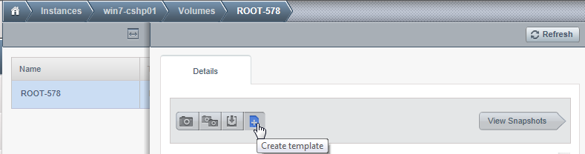

Install powershell module for active directory

As the solution requires access to active directory and needs to be able to read and write data, it’s important to have the PowerShell module for Active Directory installed on the XenDesktop delivery controller.

The module can be activated in the Windows server manager as part of a feature installation:

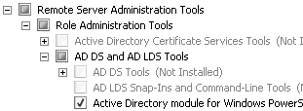

For Windows 2003 and 2008 domain controllers you also need to install Active Directory Management Gateway Service.

Installation of Citrix Self Service Desktops

The overall solution is currently packaged as two MSI files for easy installation on Windows. Both applications should be installed on the XenDesktop Controller:

* Citrix.SelfServiceDesktops.Agent.Setup.msi
* Citrix.SelfServiceDesktops.WebApp.Setup.msi

Prior to installation, create a directory named C:\CtxLogs – this is where diagnostic logs from the solution will be written.

Install the Agent first. This will typically install into a folder named C:\Program Files (x86)\Citrix\SelfServiceDesktops\Agent. In this folder is a configuration file named Citrix.SelfServiceDesktops.Agent.exe.config – you will need to edit this to define you site’s configuration (see Appendix II).

Once you have edited the configuration file, you will need to restart the Citrix Self Service Desktop Agent – from a command prompt type services.msc to get the Windows Services administration console to do this.

Once the Agent is installed, you should install the web app – as shipped this will use the configuration defined for the Agent. At present, installation is only supported to the default web site – attempts to install on other web sites will not work. Please verify your IIS prior to installation. (see Appendix I).

The web app will install to http://<your-xd-controller-address>/Citrix/SelfServiceDesktops

After that, you are ready to go. The Agent should look after itself (check C:\CtxLogs for any error messages if you encounter problems)

References

1. CloudPlatform_self-service_desktops_v02.docx
2. Setting up AD Authentication in CloudPlatform.docx
3. CloudPlatform_auto_join_vm_to_domain.docx

Appendix I – IIS Setup

Deploying Web App in IIS Default WebSite:

1. Activate the IIS Feature on your Server.

* We aim to support IIS 7.0/7.5/8.0

2. Install .NET 4.5

Download from <http://www.microsoft.com/en-gb/download/details.aspx?id=30653>

* Run as Admin
* By installing .NET 4.5 *after* activating IIS, .NET 4.5 should add itself to IIS
* After install, Microsoft .NET 4.5 should appear in “Control Panel\All Control Panel Items\Programs and Features”

3. Add IIS 7.0/7.5 fix for WebApp URL Routing

* Download from <http://support.microsoft.com/kb/980368>

Appendix II – Self Service Desktop Configuration

The Self Service Desktop apps is configured via a fragment of Xml in the app.config file for the Citrix Self Service Desktop Agent.

If the web app is deployed on the same server as the Agent, it will share its configuration. Otherwise the same configuration section must be inserted into the Web.config file of the web app and maintained in parallel.

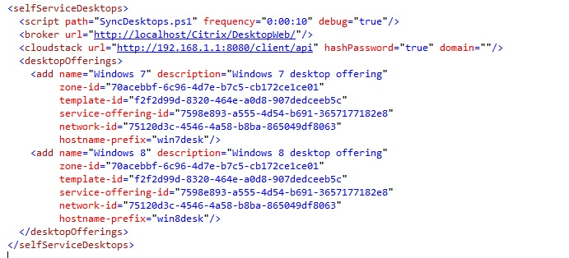

The configuration should be relatively self explanatory. The script element should not be modified, the cloudstack and desktopOfferings elements should be edited to fit your local deployment. If you have Active Directory integration in your CloudPlatform, then hashPassword=false is probably the correct option.